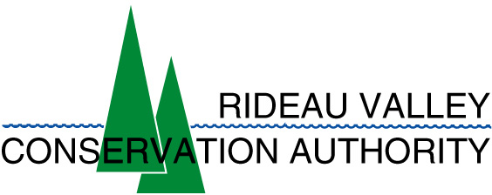 | Shoreline Classification Methods.  Rideau River Shoreline Classification Project

Healthy and productive shorelines are valuable resources which if properly managed in a sustainable manner can provide social, economic and environmental benefits.

A shoreline that is bordered with natural vegetation (instead of human development such as retaining walls) can aid in stabilizing slopes and help in filtering water by removing various sediments and pollutants including pesticides. By restricting access to the water by domesticated animals (such as cows) and allowing a buffer zone of trees along the waters edge, a well-managed shoreline can also help reduce nutrients from both animal and human sources. | 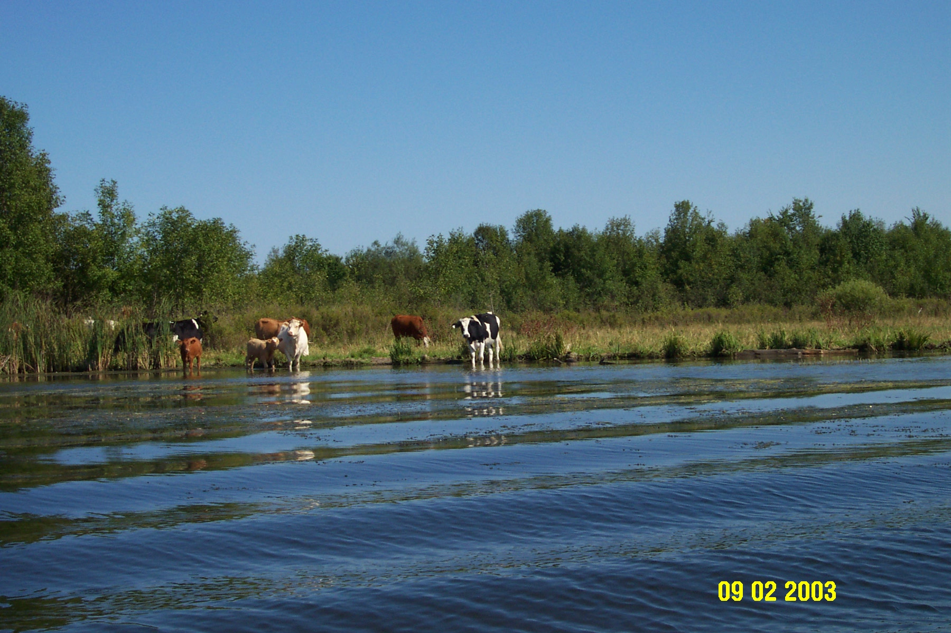  Cows should NOT be on the shore or in the river!

Management of the shoreline requires up-to-date knowledge of features that comprise the shoreline as well as the riparian and littoral zones. These features should be mapped and stored in a GIS (geographic information system) for mapping and analysis purposes. By applying a systematic analysis of various shoreline, riparian and littoral features the health and effectiveness of the shoreline can be determined. As well, if the shoreline areas are mapped in the future using the same criteria, then change detection procedures can be employed to determine if the health of the shoreline has improved, degraded or has remained in a constant state.

Three organizations (* CSW and * RVCA, Parks Canada?) have cooperated to do such an analysis of a section of the Rideau River between Smiths Falls and Ottawa in Ontario, Canada.  A version of M.A.P.L.E. (Mutual Association for the Protection of Lake Environment) was modified and expanded to map the shoreline features of all properties along the Rideau River study area in 2002 and 2003. | 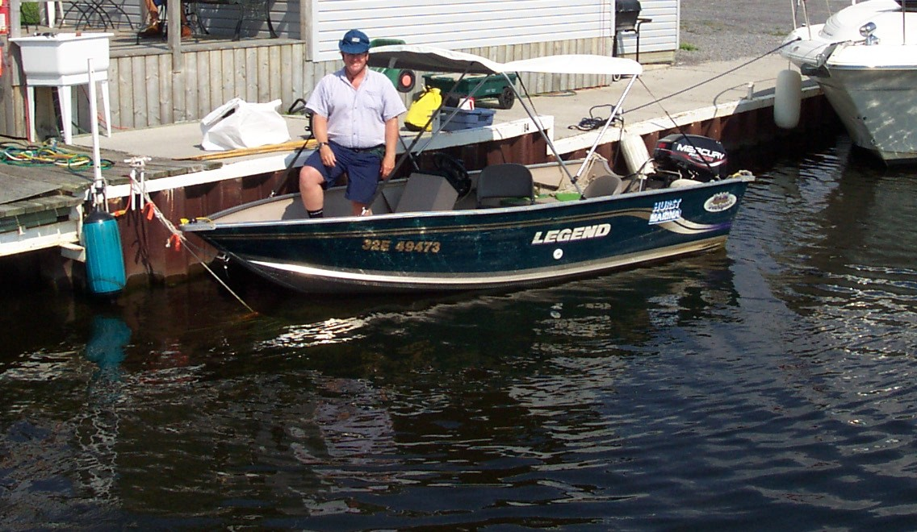  RVCA Shoreline Technician Michael Kostiuk (2003).
Most of the fieldwork was done via small powerboats, which allowed access to relatively shallow inshore areas. | A good example of cooperation with local stakeholders of the Rideau River system!  The survey watercraft was donated by Hurst Marina on the Rideau River at Manotick (a community located in the southern section of the City of Ottawa).

RCVA web site: www.rideauvalley.on.ca. Michael Kostiuk web site: www.michaelkostiuk.com

* RVCA: Rideau Valley Conservation Authority. * CSW: Centre for Sustainable Watersheds.

