What is the Meaning of OM MANI PADME HUM?

The Meaning of Om
The mantra OM is the name of God. Written as A-U-M, it represents the divine energy united in its three aspects: Brahma (creation), Vishnu (preservation) and Shiva (destruction); or Buddhists will relate it to holy body, holy speech and holy mind of Buddha.

Swami Sivananda about the Meaning of Om and Om Meditation
'Om (Aum) is everything. Om is the Name or symbol of God, Isvara or Brahman. Om is your real Name. Om covers the whole threefold experience of man. Om stands for the phenomenal worlds. From Om this sense-universe has been projected. The world exists in Om and dissolves in Om. ‘A’ represents the physical plane. ‘U’ represents themental and astral plane, the world of intelligent spirits, all heavens. ‘M’ represents the whole deep sleep state, and all that is unknown even in your wakeful state, all that is beyond the reach of your intellect. Om represents all, Om is the basis of your life, thought and intelligence. Om is everything. All words which denote objects are centred in Om. Hence the whole world has come from Om, rests in Om, and dissolves in Om. As soon as you sit for meditation, chant Om loudly 3 or 6 or 12 times. This will drive away all worldly thoughts from the mind and remove Vikshepa (tossing of mind). Then take to the mental repetition of Om.
The Japa of Om (Pranava Japa) has a tremendous influence on the mind... The vibrations set up by this word are so powerful that, if one persists in taking recourse to them, they would bring the largest building to the ground... Pronounced as spelt, it will have a certain effect upon the student; but pronounced in its correct method, it arouses and transforms every atom in his physical body, setting up new vibrations and conditions, and awakening the sleeping power of the body.'

MANI means Jewel
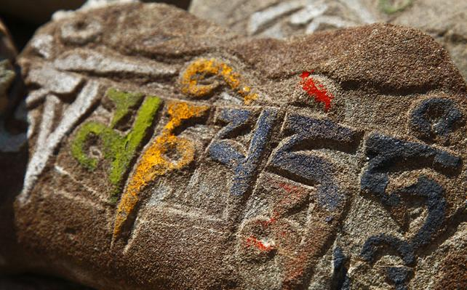Pure Jewel stands for love and compassion and it also symbolizes the intention to become enlightened. Jewel within the manifested world could be seen as Maya, the appearance of: desires, samsara, nirvana...

PADME is Lotus symbolizing wisdom
Just as a lotus grows forth from mud, wisdom has to fight its way through the human conditioning to get realised as a divine quality. The main of all wisdoms is the wisdom of silence and emptiness. PADME signifies emptiness.

HUM unifies spiritual methods with wisdom
It is the indivisibility, the immovable, that which cannot be disturbed. It represents the spirit of enlightenment. HUM destroys the suffering. It is an imperative: May your holy mind, and your great compassion enter my heart!
MANI signifies appearance, PADME signifies emptiness, HUM unifies the two.
MANI is the illusion, PADME is the light, and HUM unifies the two.

